**SAVEETHA SCHOOL OF ENGINEERING**

**CSA1142-OBJECT ORIENTED ANALYSIS AND DESIGN**

**QUESTION 15: BLOOD BANK SYSTEM**

**USE CASE**

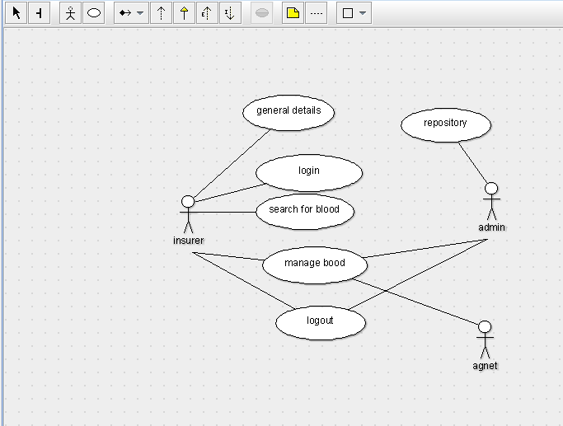

STATE DIAGRAM

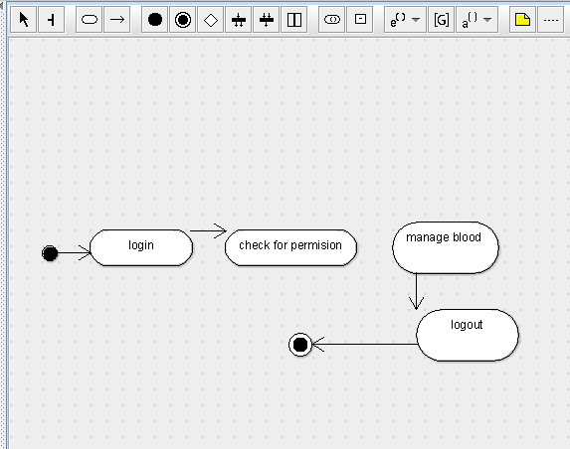

SEQUENCE DIAGRAM

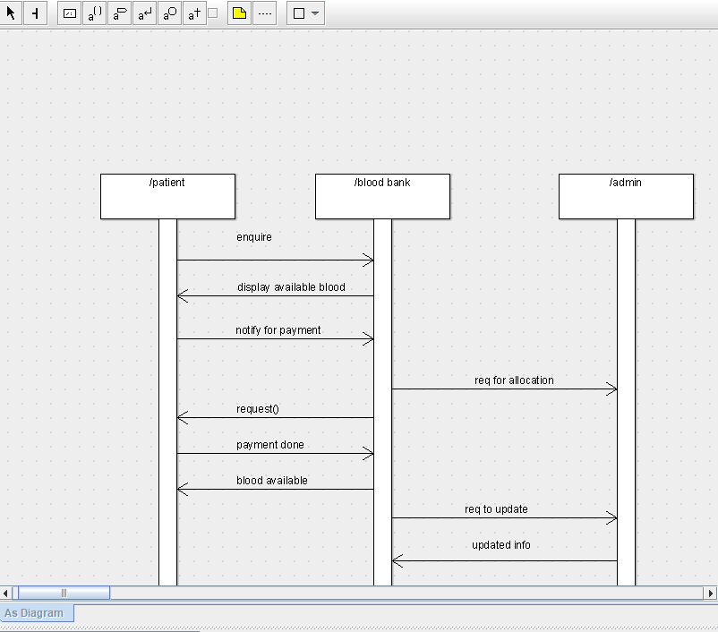

DEPLOYMENT DIAGRAM

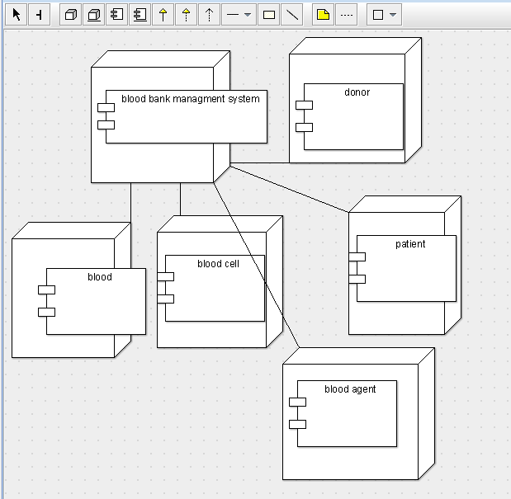

COMPONENT DIAGRAM

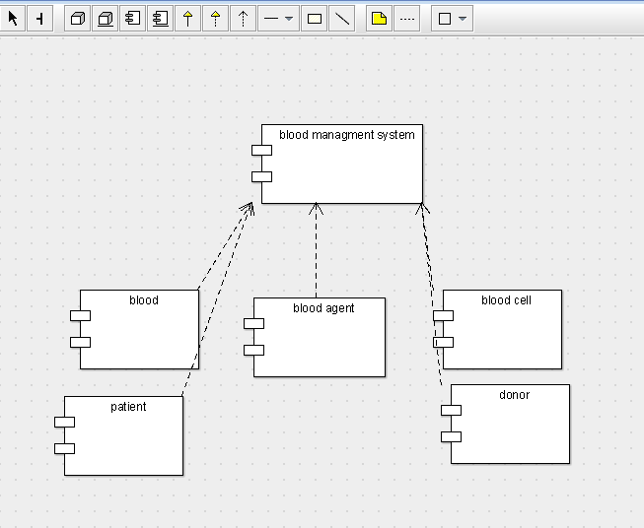

COLLABORATION DIAGRAM

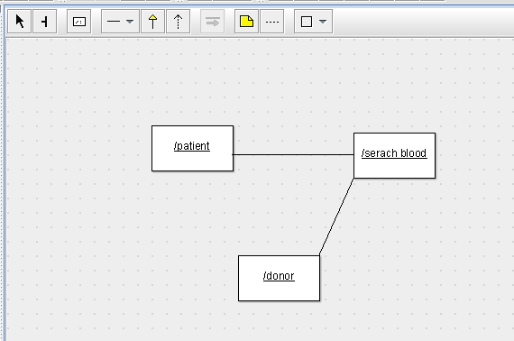

CLASS DIAGRAM

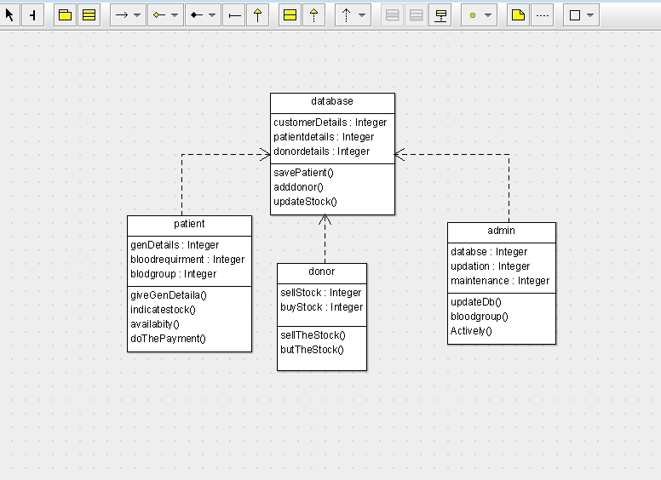

ACTIVITY DIAGRAM

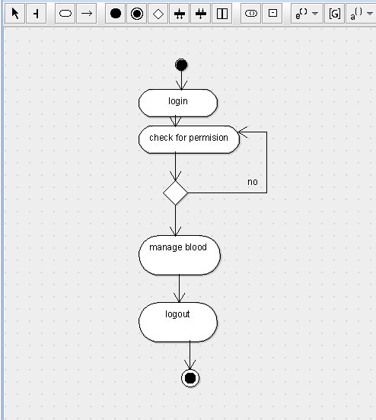

SKELETON CODE;

public class database {

  public Integer customerDetails;

  public Integer patientdetails;

  public Integer donordetails;

  public void savePatient() {

  }

  public void adddonor() {

  }

  public void updateStock() {

  }

}

public class donor {

  public Integer sellStock;

  public Integer buyStock;

  public void sellTheStock() {

  }

  public void butTheStock() {

  }

}

public class patient {

  public Integer genDetails;

  public Integer bloodrequirment;

  public Integer blodgroup;

  public void giveGenDetaila() {

  }

  public void indicatestock() {

  }

  public void availabity() {

  }

  public void doThePayment() {

  }

}

public class admin {

  public Integer databse;

  public Integer updation;

  public Integer maintenance;

  public void updateDb() {

  }

  public void bloodgroup() {

  }

  public void Actively() {

  }

}